SIT???

UNIT NAME

TIEN PHAT NGUYEN

223171213

Learning Summary Report

Update header with your name and ID. Then delete this box.

# Self-Assessment Details

The following checklists provide an overview of my self-assessment for this unit.

|  |  |  |  |  |
| --- | --- | --- | --- | --- |
|  | Pass (D) | Credit (C) | Distinction (B) | High Distinction (A) |
| Self-Assessment |  |  | ✓ |  |

Self-Assessment Statement

# Declaration

I declare that this portfolio is my individual work. I have not copied from any other student’s work or from any other source except where due acknowledgment is made explicitly in the text, nor has any part of this submission been written for me by another person.

Signature: **Tien Phat Nguyen**

# Portfolio Overview

This portfolio includes work that demonstrates that I have achieved all Unit Learning Outcomes for SIT330 Unit Title to a Distinction level.

My learning journey in SIT330 began with a foundational understanding of text data processing, where my initial knowledge was limited to basic concepts of natural language processing (NLP). Through the course, I immersed myself in the comprehensive study of document processing techniques, which included information retrieval, text mining, and machine learning algorithms. A significant milestone in my journey was developing software solutions that leveraged NLP tools to solve real-world problems. This not only solidified my theoretical knowledge but also enhanced my practical skills. Overcoming challenges such as complex document classification and natural language understanding tasks required critical thinking and problem-solving abilities. Additionally, improving my communication skills by explaining complex NLP concepts to both technical and non-technical audiences was a crucial part of my growth.

I believe I should receive a Distinction grade because I have consistently applied all Unit Learning Outcomes in my tasks. For ULO1, I have effectively communicated NLP concepts and algorithms to diverse audiences through detailed presentations and comprehensive reports. For ULO2, I designed and developed multiple software solutions that utilized NLP tools to address real-world problems, providing clear justifications for my approaches. For ULO3, I clearly articulated the methodologies and approaches in my software solutions to a broad audience, ensuring clarity and understanding. For ULO4, I have continually reflected upon my learning experiences, documented my progress, and presented compelling evidence of my achievements in a well-structured manner.

The tasks I have completed, which are attached to this portfolio, provide robust evidence of my ability to apply the Unit Learning Outcomes in practical and meaningful ways. Each task showcases my discipline-specific knowledge, digital literacy, critical thinking, problem-solving skills, communication abilities, and self-management. I have consistently met and exceeded the expectations for distinction-level work, demonstrating my comprehensive understanding and application of complex NLP concepts. Therefore, I believe my work justifies the awarding of a Distinction grade.

# Reflections

## The most important things I learnt:

The most important things I learnt in this unit were the comprehensive methodologies and technologies involved in processing and analyzing large-scale text data. I gained a deep understanding of document processing techniques, which are essential for extracting valuable information from vast amounts of text data. This included learning about information retrieval, text mining, machine learning algorithms, and their applications in natural language processing (NLP). The unit met my expectations by providing a solid theoretical foundation as well as practical skills in these areas.

## I feel I learnt these topics, concepts, and/or tools really well:

I feel I learnt the following topics and tools really well:

* **Natural Language Processing (NLP)**: I now have a strong grasp of NLP concepts and can confidently apply them to real-world problems.
* **Information Retrieval and Indexing**: Understanding how to efficiently retrieve and index information was a key learning outcome.
* **Machine Learning Algorithms**: I am proficient in applying machine learning algorithms to text data for various analytical purposes.
* **Document Classification and Information Extraction**: I can effectively classify documents and extract meaningful information from semi-structured text.

## I found the following topics particularly challenging:

I found the following topics particularly challenging:

* **Complex Document Classification**: Mastering the techniques for accurately classifying complex documents was a significant challenge.
* **Natural Language Understanding**: Understanding and implementing algorithms for natural language understanding required substantial effort and critical thinking.

Despite these challenges, I was able to overcome them through persistent practice and seeking additional resources. I learned that I have the resilience and problem-solving skills needed to tackle difficult concepts.

## I found the following topics particularly interesting:

I found the following topics particularly interesting:

* **Vector Space Model**: The application of the vector space model in information retrieval was fascinating and highly valuable for understanding document similarities.
* **Probabilistic IR and Evaluation of Retrieval Systems**: Learning about probabilistic models and how to evaluate the performance of retrieval systems was enlightening.

These topics not only enhanced my technical knowledge but also provided insights into the practical applications of these concepts in the industry.

## I still need to work on the following areas:

I still need to work on the following areas:

* **Advanced NLP Techniques**: I plan to further my understanding of advanced NLP techniques such as deep learning applications in NLP.
* **Continuous Improvement in Coding Skills**: I aim to continue improving my coding skills, particularly in optimizing algorithms for better performance.

## The things that helped me most were:

The things that helped me most were:

* **Access to Comprehensive Resources**: The unit provided excellent resources, including lecture notes, recommended readings, and online tutorials, which were crucial for my learning.
* **Practical Assignments**: Hands-on assignments and projects helped me apply theoretical knowledge to practical problems, solidifying my understanding.

These resources and activities were instrumental in achieving the learning outcomes and enhancing my skills.

## My progress in this unit was …:

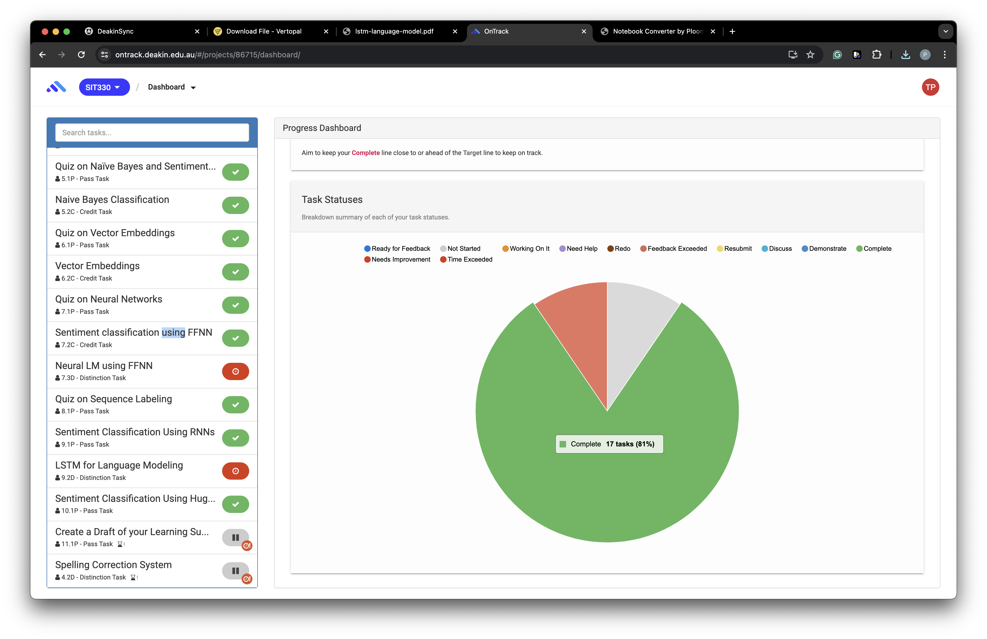

## If I did this unit again, I would do the following things differently:

If I did this unit again, I would do the following things differently:

* **Better Time Management**: Allocating more time for the challenging topics earlier in the unit would have reduced stress and improved my understanding.
* **Engage More with Peer Discussions**: Participating more in peer discussions and study groups could have provided additional perspectives and insights.

These changes would help me maximize my learning experience and achieve even better outcomes in future units.